Question -1 Write a program to print MySirG 5 times on the screen.

Ans.

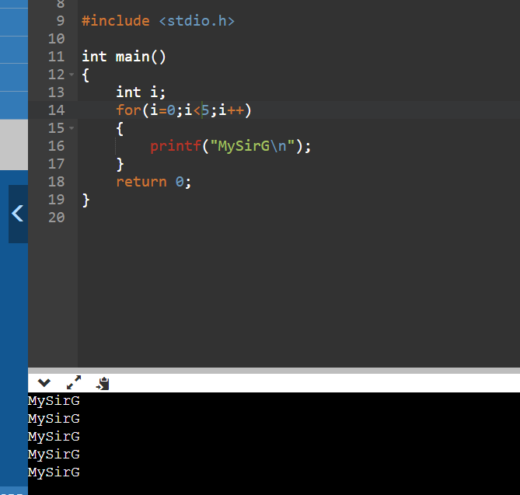

Question – 2 Write a program to print the first 10 natural numbers.

Ans.

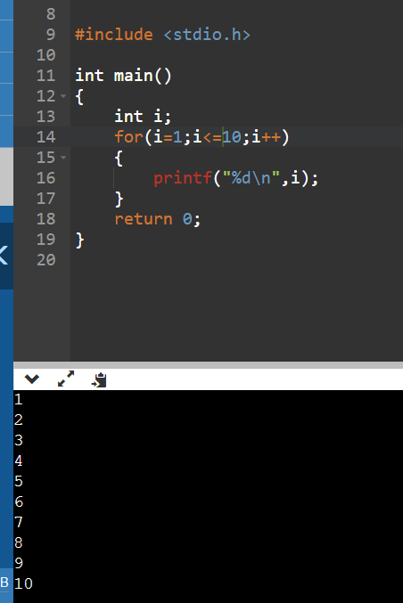

Question – 3 Write a program to print the first 10 natural numbers in reverse order.

Ans.

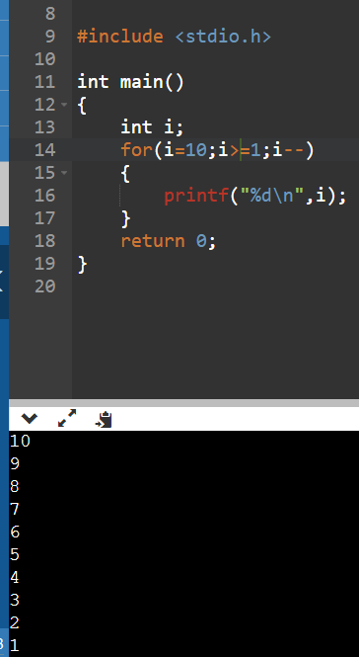

Question – 4 Write a program to print the first 10 odd natural numbers.

Ans.

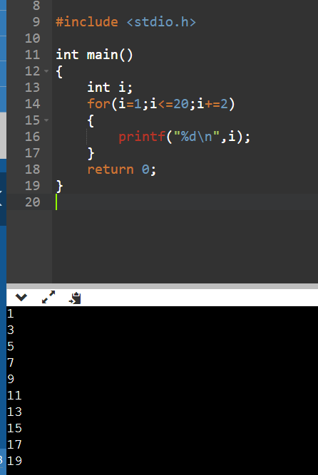

Question – 5 Write a program to print the first 10 odd natural numbers in reverse order.

Ans.

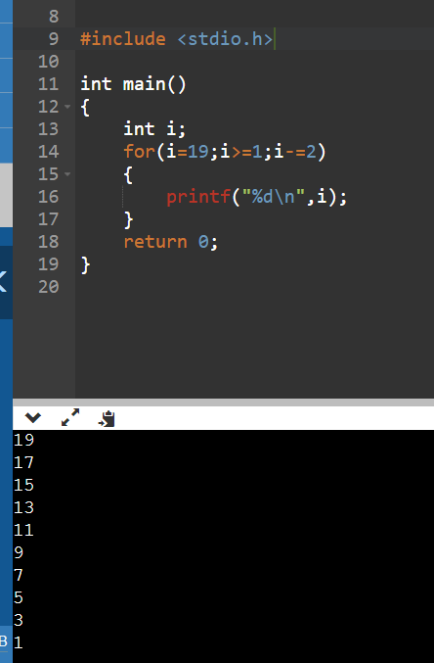

Question – 6 Write a program to print the first 10 even natural numbers.

Ans.

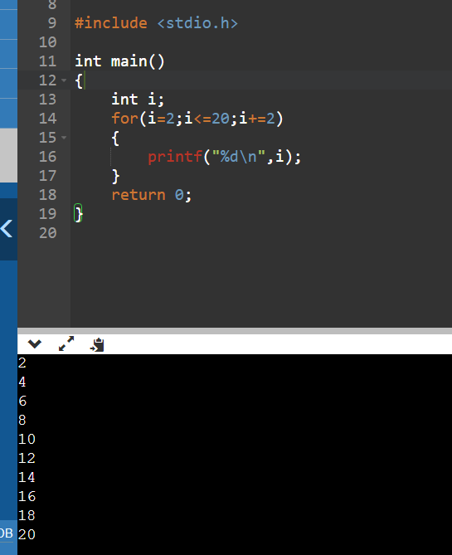

Question – 7 Write a program to print the first 10 even natural numbers in reverse order.

Ans.

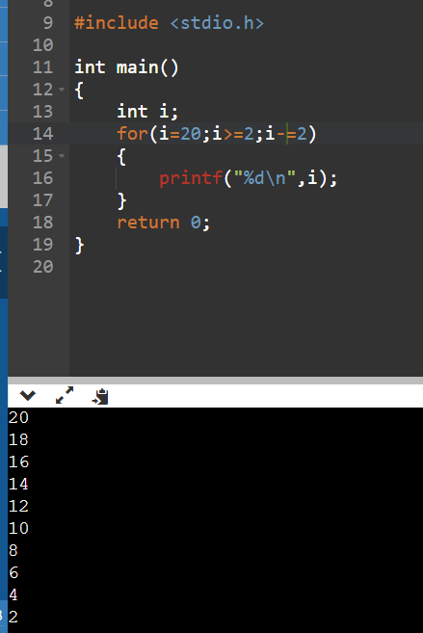

Question – 8 Write a program to print squares of the first 10 natural numbers.

Ans.

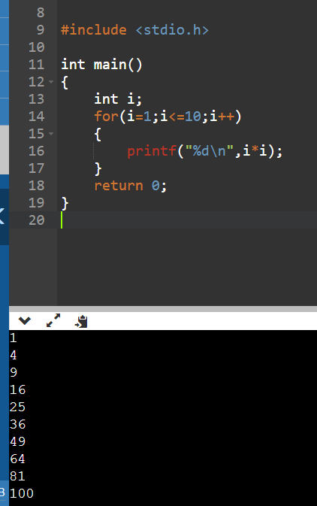

Question – 9 Write a program to print cubes of the first 10 natural numbers.

Ans

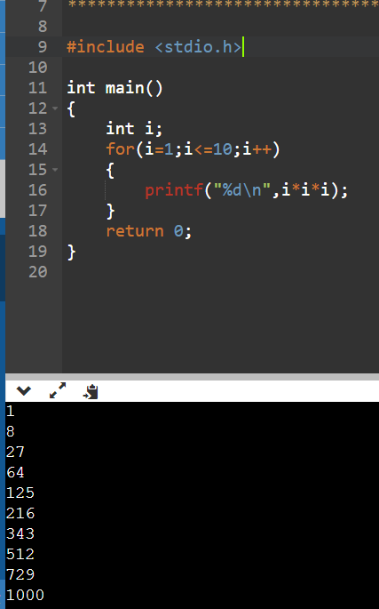

Question – 10 Write a program to print a table of 5.

Ans.

